db.students.insertMany([
{
student_id: 1,
name: "Amit",
age: 20,
marks: 85,
department: "CSE",
subjects: ["DBMS", "OS", "CN"],
email: "amit@gmail.com"
},
{
student_id: 2,
name: "Neha",
age: 22,
marks: 72,
department: "ECE",
subjects: ["Signals", "VLSI"],
email: null
},
{
student_id: 3,
name: "Rahul",
age: 19,
marks: 90,
department: "CSE",

subjects: ["DBMS", "AI", "ML"]
},
{
student_id: 4,
name: "Sneha",
age: 21,
marks: 65,
department: "IT",
subjects: ["Web", "DBMS"],
email: "sneha@gmail.com"
},
{
student_id: 5,
name: "Karan",
age: 23,
marks: 78,
department: "CSE",
subjects: ["CN", "OS"],
email: "karan@gmail.com"
}
]);

- Find students with marks greater than 80.
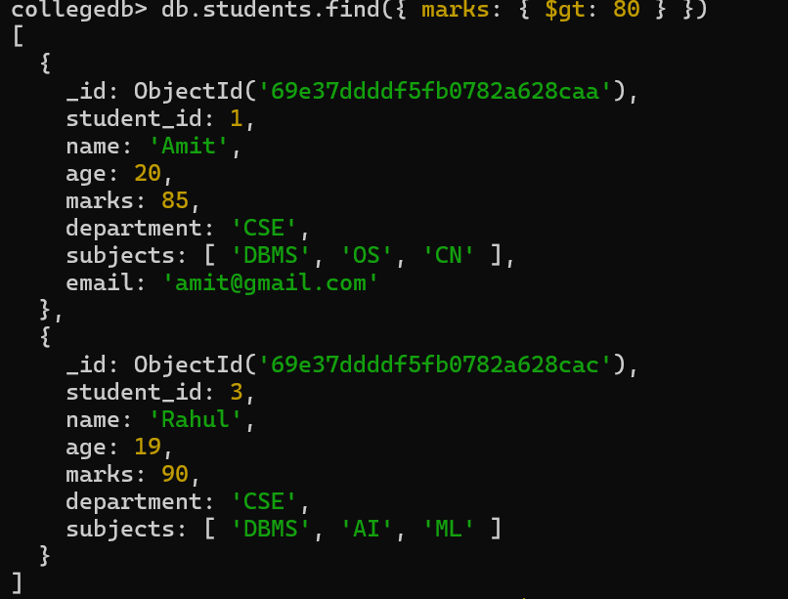

2.Find students aged less than or equal to 20.
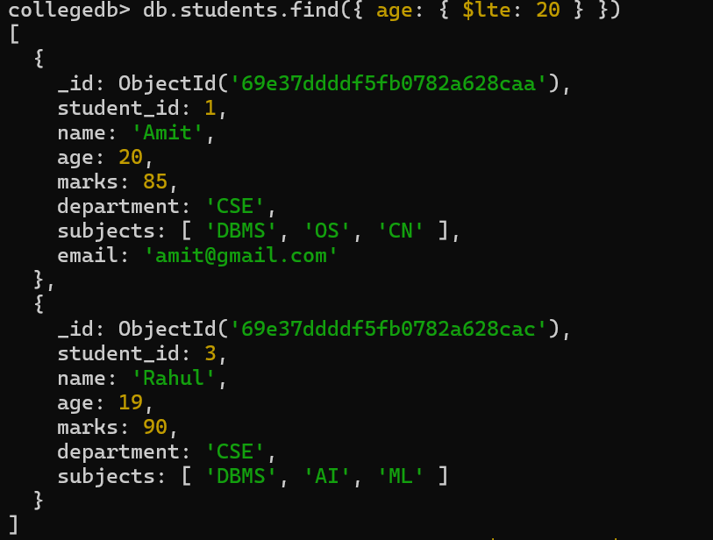
3. Find students with marks between 70 and 85.
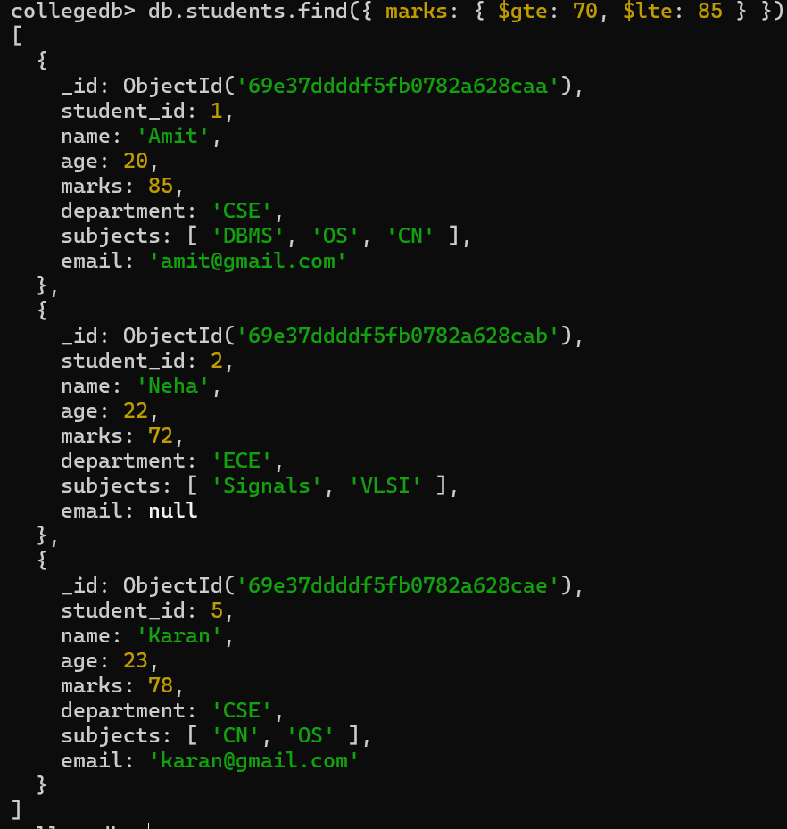
4. Find students not belonging to CSE department.
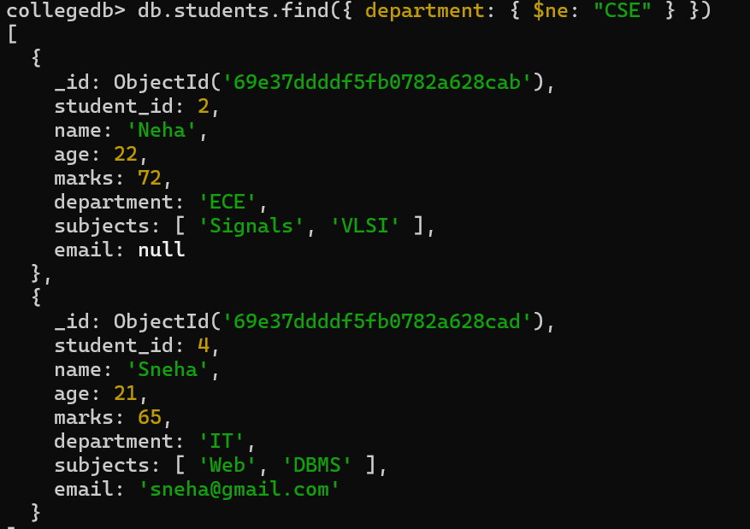

5. Find students whose age is exactly 21.
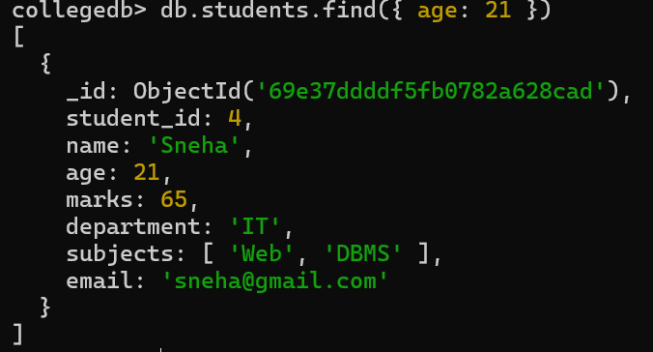
6. Find students with marks less than 75.

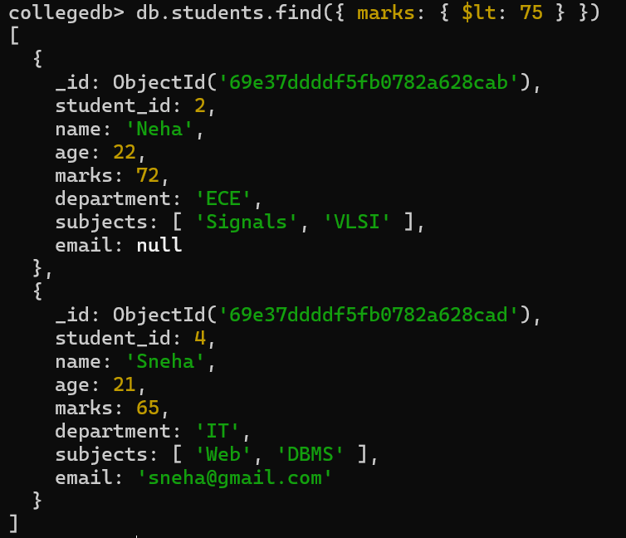
7. Find students whose department is either CSE or IT.
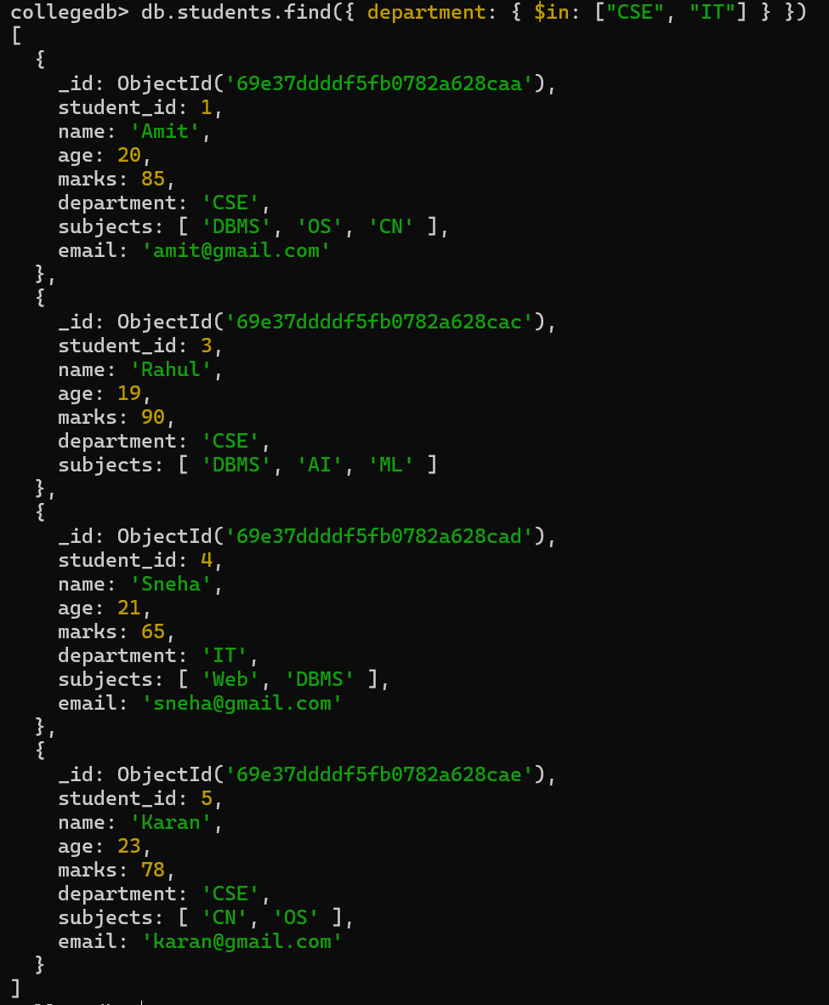
8. Find CSE students with marks above 80

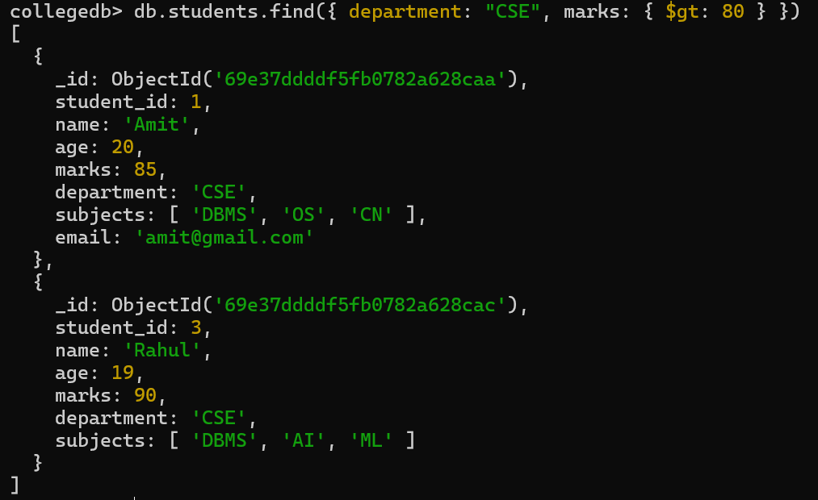
9. Find students who are in CSE or have marks above 85
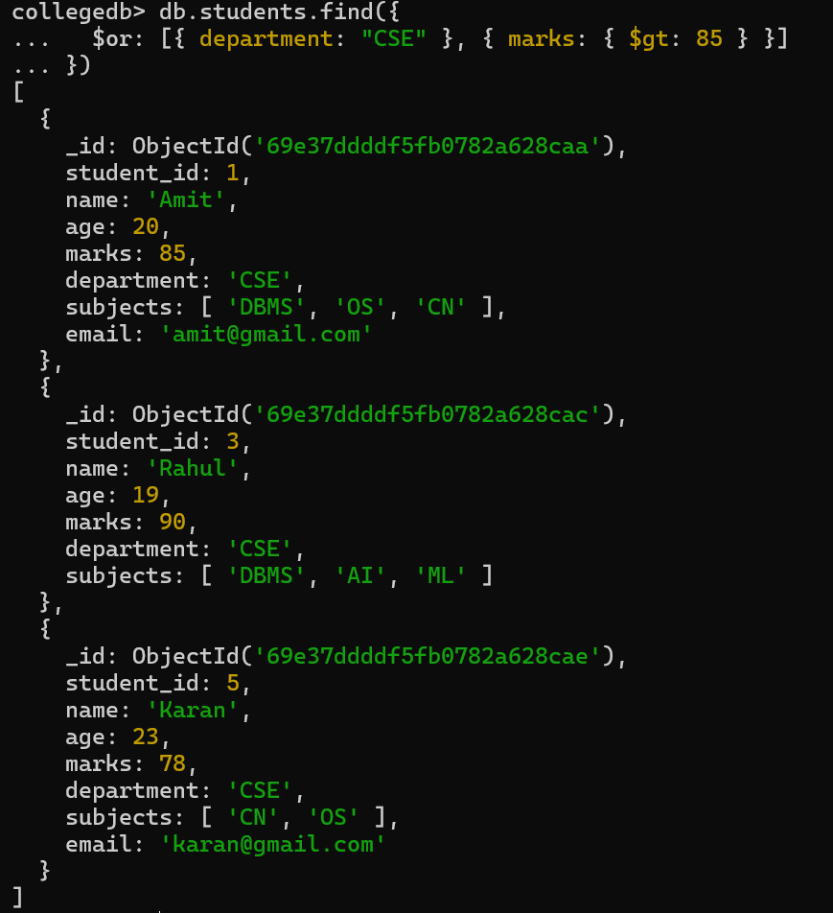

10. Find students who are NOT in IT department.

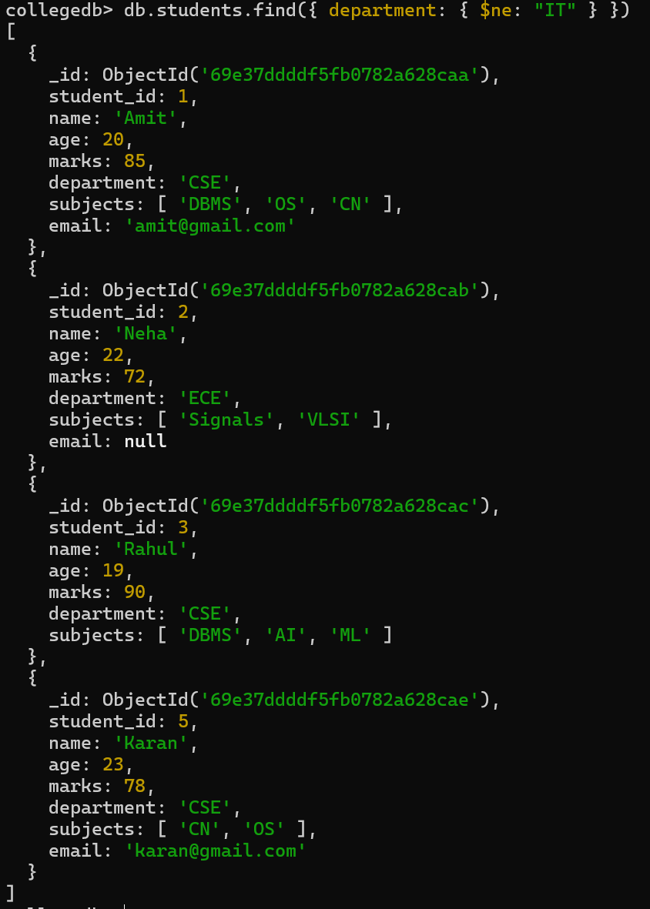

11. Find students with marks not between 70 and 85.
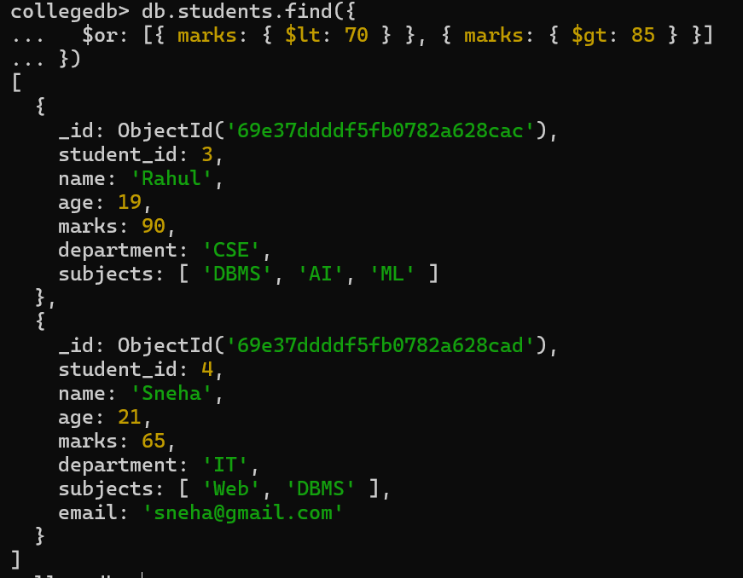

12.Find students aged above 20 and not in ECE.
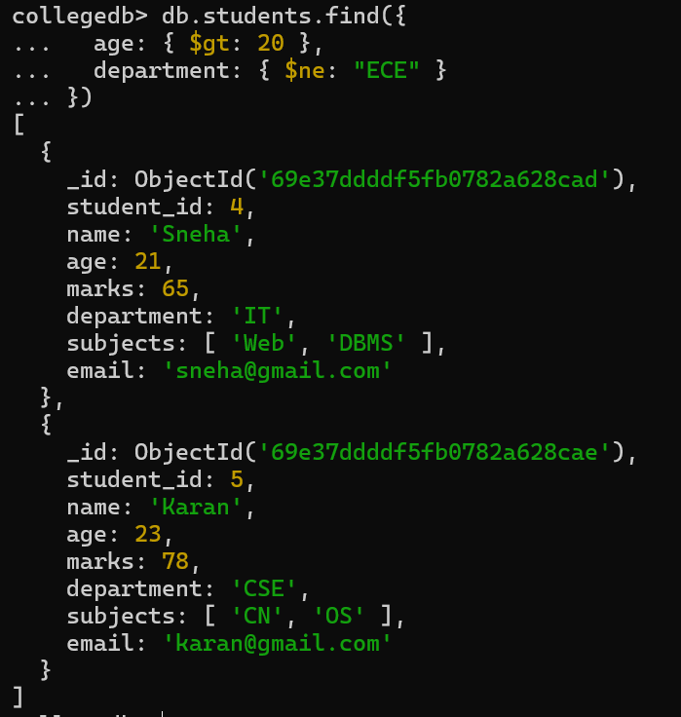
13. Find students who are either IT students or have marks less than 70.
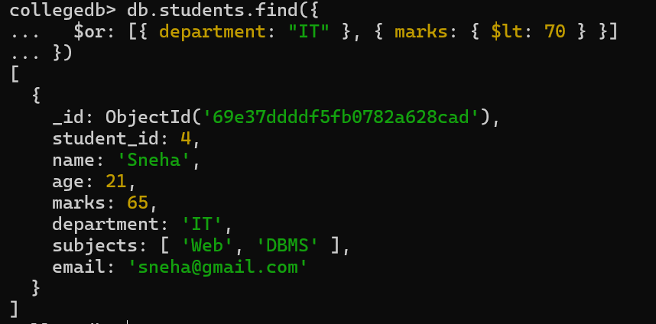

14. Find students who are not CSE and not IT.
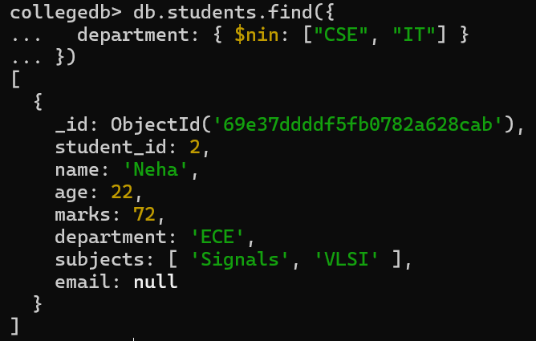
15.Find students who have an email field.
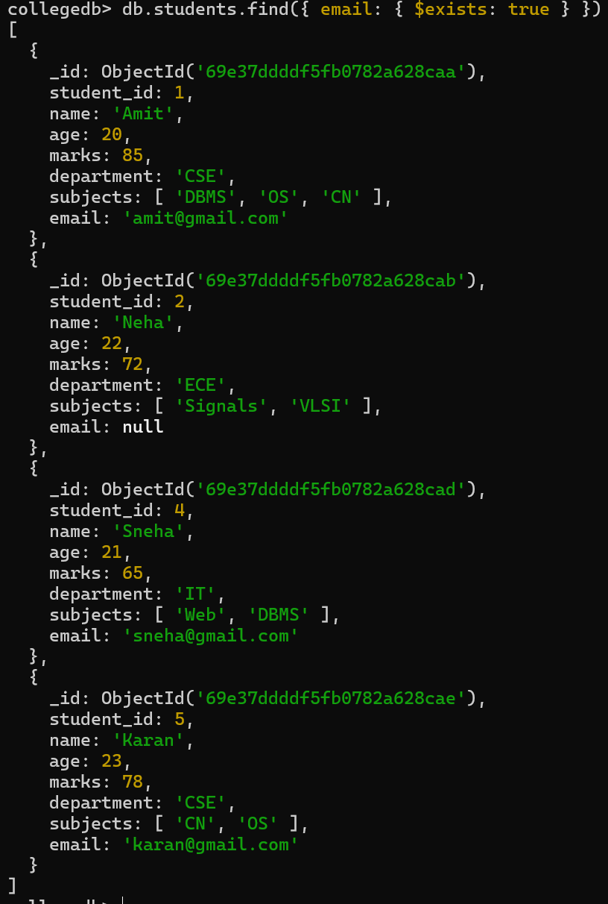

16. Find students who do not have an email field.

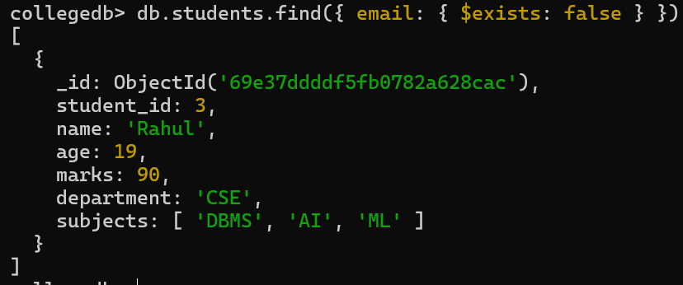

17. Find students whose email value is null.
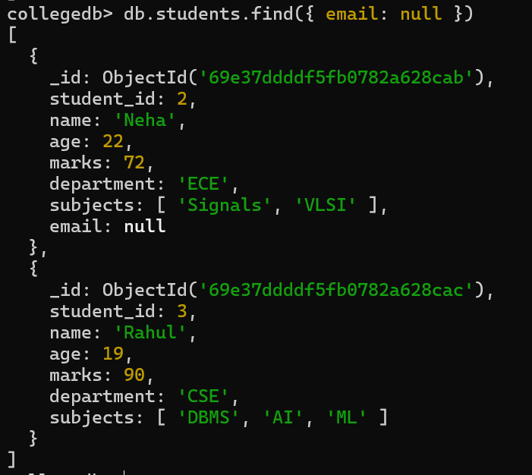
18. Find students whose marks field is of type integer.
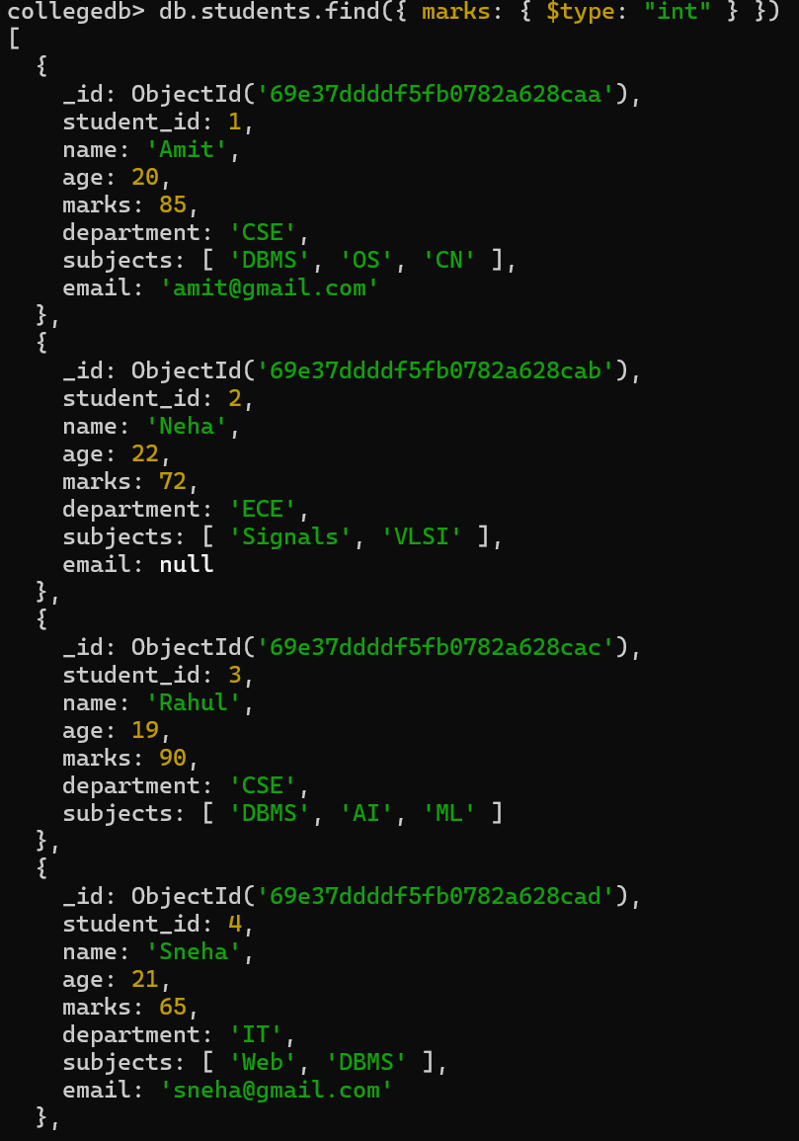

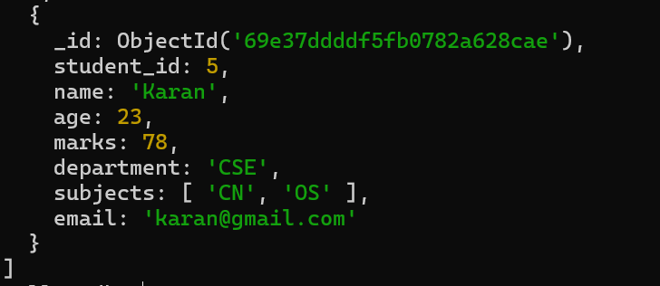

19. Find students who have subjects’ field.

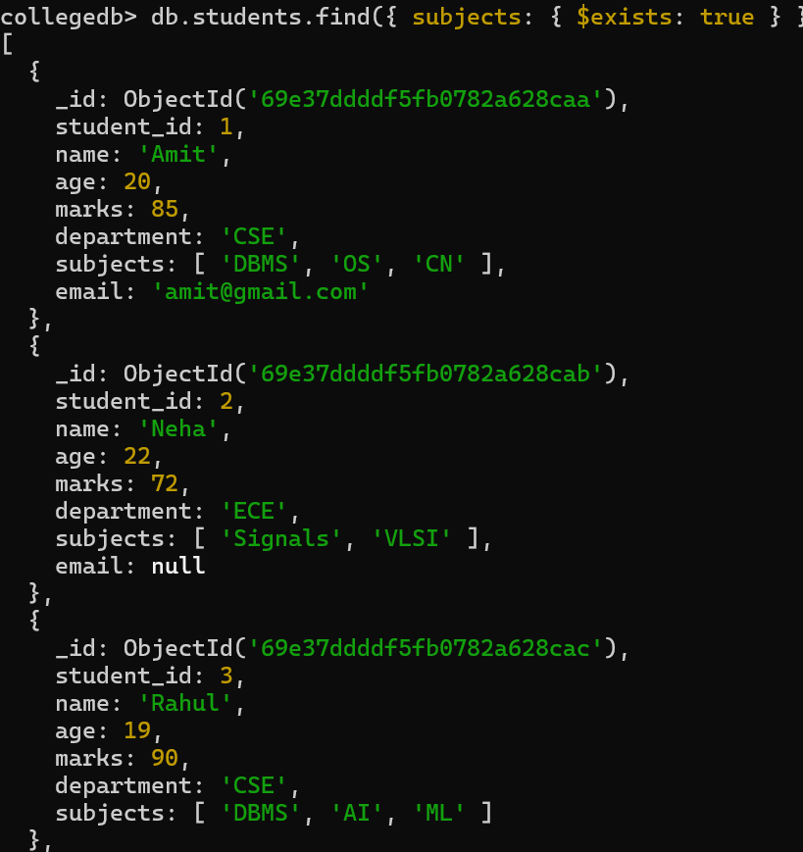
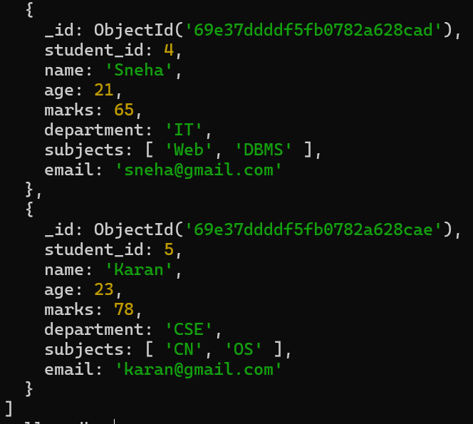

20.Find students whose age field is missing.
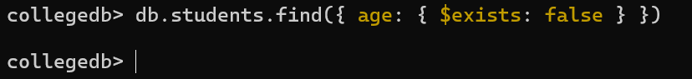
21. Find students where marks modulo 5 equals 0.
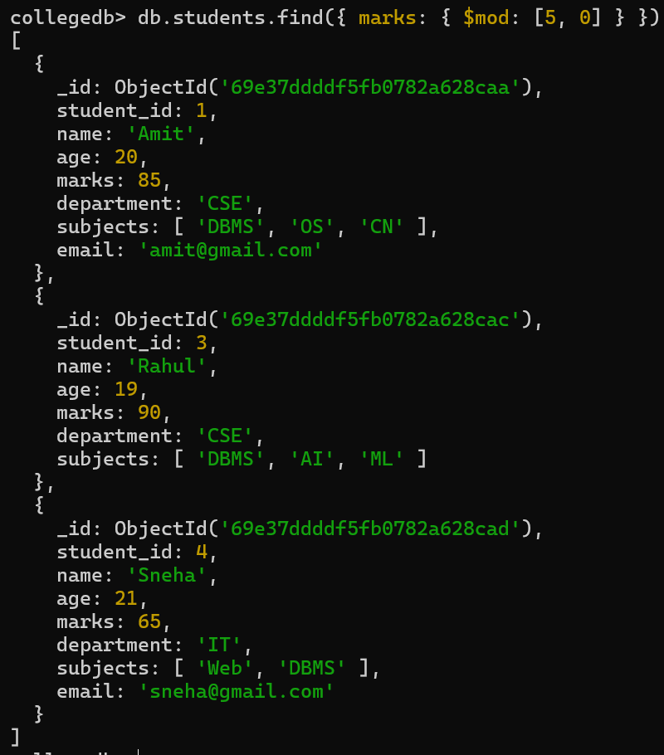

22. Find students whose name starts with letter “A”.

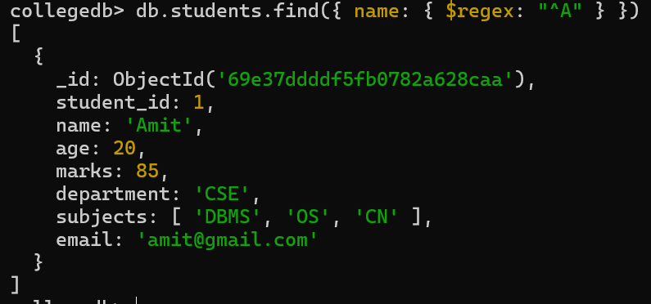

23. Find students whose email ends with gmail.com.
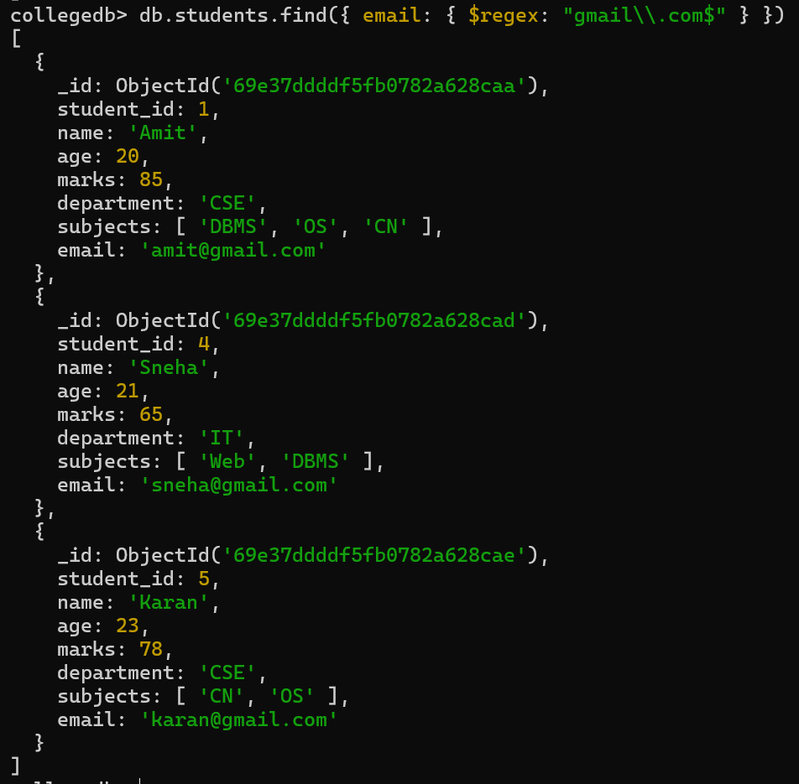
- 24. Find students who have more than 2 subjects.
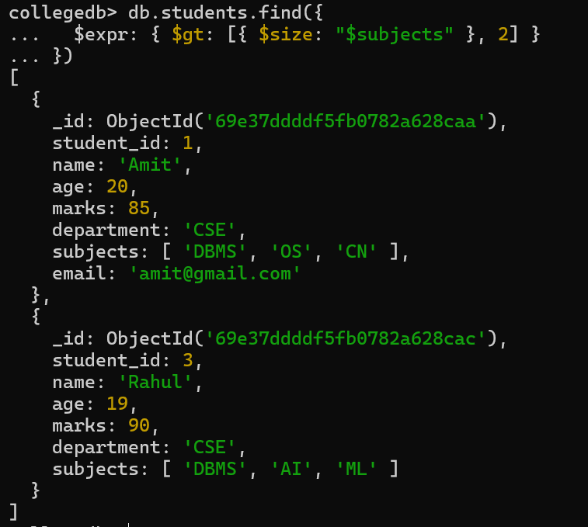
25.Find students whose marks are greater than their age × 3.

